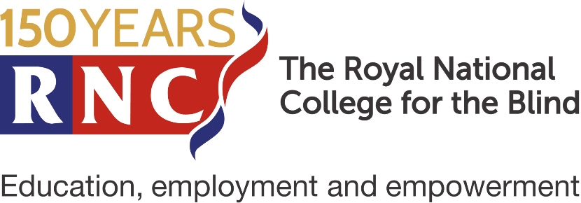

‘Have a Go’ Weekend Application Form
Saturday 22nd and Sunday 23rd October 2022

The Royal National College for the Blind (RNC)
Venns Lane, Hereford HR1 1DT

If you need any help completing this form, please contact the Student Enquiries Team on 01432 276 725 or email info@rnc.ac.uk

- The RNC Have a Go weekend is a free event for young people aged 13 to 17 years.
- The weekend runs from 11am on Saturday and finishes at approximately 3pm Sunday. It involves one overnight stay in free accommodation for the young person and any accompanying adults.
- We would expect the young person to be accompanied by one responsible adult. Additional adults are welcome, as are siblings.
- We find that young people have a great time, enjoy getting to know each other and making new friends. Their programme is completely separate from that of the accompanying adults, which gives the latter an enjoyable break and the young people a taste of independence.

- The Adults Programme involves several useful Information and advice sessions, and adults are free to enjoy their spare time, maybe exploring Hereford city centre.

- All attendees are provided with Saturday lunch, an evening meal on Saturday evening with breakfast and lunch on Sunday.

- The young people’s programme often includes an off-campus activity, whilst the adults remain on the College grounds.

- Our experienced support team will make sure the young people are kept safe and entertained throughout their stay.

Young Person Details
Full name
Known as
Home Address
(including postcode)
Date of Birth

Accompanying Adult Details
Relationship to Young Person
Full name
Known as
Home Address
(including postcode)
Phone Number
Email Address

Additional Accompanying Adult Details (if applicable)
Relationship to Young Person
Full name
Known as
Home Address
(including postcode)
Phone Number
Email Address

Accompanying Siblings (if applicable)
Sibling 1 Known as
Sibling 1 Age
Sibling 2 Known as
Sibling 2 Age

Medical Information
Is the young person registered blind or partially sighted?
What eye condition(s) does the young person have?
How does this affect the young person?
Are there any additional medical conditions, illnesses, injures or allergies that you think we need to be made aware of?
Please list any medication prescribed which the young person will need take during the weekend
Is the young person able to self-medicate?
If no, what assistance is required?

Mobility Information
Does the young person use any mobility aid? E.g. long cane or guide dog.
Is the young person a wheelchair user?
Please provide any information that you think may be relevant.

Additional Information
What is their preferred reading format? e.g. standard print, large print, braille, audio.
Does the young person have any special dietary requirements?
If the young person is currently in education, what is the Name and Location of School/College?
Please state any VI Organisations that you are a member of?
If travelling by car, please write the vehicle’s registration number.

What are your interests and hobbies?

How did you hear about the Have a Go weekend?

Parental Consent for Medical Attention
In the event that any young person is injured during any activities, and their parent / guardian cannot be contacted, medical treatment may need to be administered.
I give consent for my child to receive medical attention. | Yes / No
Signature | Date
Print Full Name

Parental Consent for Photography
During the weekend, RNC may be taking photographs and video footage which may be used for promotional literature, including prospectus, website and social media.
I am happy for my child to be filmed and photographed. | Yes / No
Signature | Date
Print Full Name

Please note that by completing this form your details will be held on our student record system and will be used for the purpose of administration, guidance and monitoring. As part of administration process we will send you information and communication relating to your application and admission. Please see our Privacy Policy on our website www.rnc.ac.uk/privacy-policy

Please email the form to:
info@rnc.ac.uk

Or, post the form to:
Student Recruitment Team
The Royal National College for the Blind
Venns Lane, Hereford, HR1 1DT

